Create a React Application named “officespacerentalapp” which uses React JSX to create elements, attributes and renders DOM to display the page

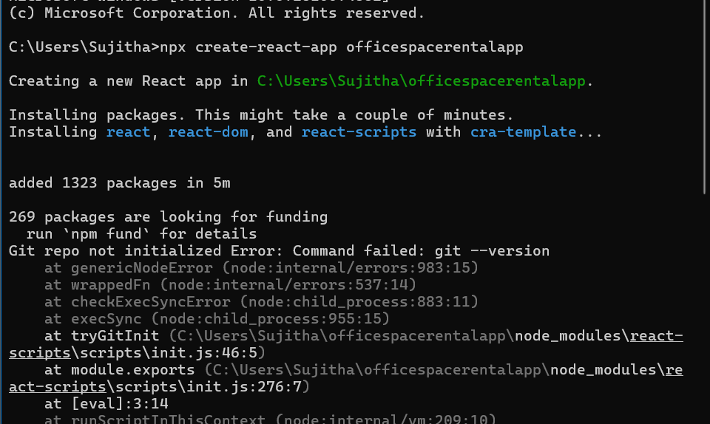

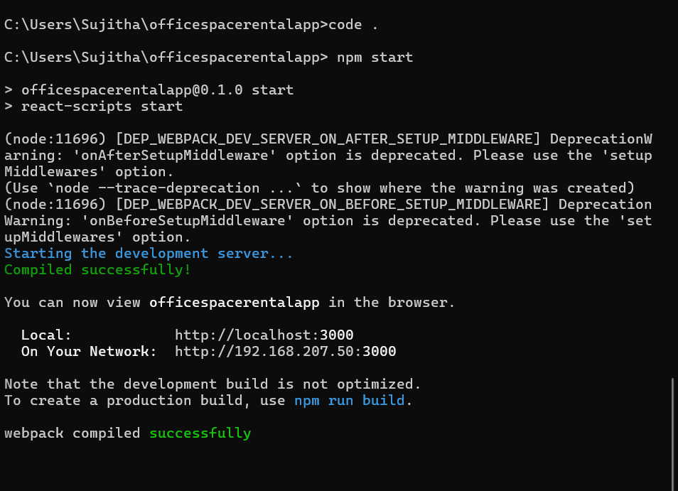

**App.js**

import React from 'react';

import './App.css';

function App() {

  const offices = [

    { name: 'Innovative Workspace', rent: 45000, address: '123 Main St, Chennai' },

    { name: 'Tech Park View', rent: 75000, address: '456 IT Road, Bangalore' },

    { name: 'Startup Hub', rent: 58000, address: '789 Biz Ave, Hyderabad' }

  ];

  return (

    <div className="app-container">

      <h1 className="main-heading">Office Space Rental Listings</h1>

      <img src="/office.jpg" alt="Office space" className="office-image" />

      <div className="office-list">

        {offices.map((office, index) => (

          <div key={index} className="office-card">

            <h2>{office.name}</h2>

            <p className={`rent ${office.rent > 60000 ? 'high' : 'low'}`}>

              Rent: ₹{office.rent}

            </p>

            <p className="address">Address: {office.address}</p>

          </div>

        ))}

      </div>

    </div>

  );

}

export default App;

**App.css**

.app-container {

  text-align: center;

  font-family: 'Segoe UI', Tahoma, Geneva, Verdana, sans-serif;

  padding: 40px;

  background-color: #f5f7fa;

}

.main-heading {

  font-size: 32px;

  color: #333;

  margin-bottom: 20px;

}

.office-image {

  width: 500px;

  border-radius: 8px;

  margin-bottom: 30px;

  box-shadow: 0 4px 12px rgba(0, 0, 0, 0.2);

}

.office-list {

  display: flex;

  flex-direction: column;

  align-items: center;

}

.office-card {

  background-color: #ffffff;

  padding: 20px;

  width: 500px;

  border: 1px solid #ddd;

  border-radius: 12px;

  margin-bottom: 20px;

  box-shadow: 0 2px 10px rgba(0, 0, 0, 0.05);

  text-align: left;

}

.office-card h2 {

  margin-top: 0;

  font-size: 24px;

  color: #222;

}

.rent {

  font-size: 18px;

  font-weight: bold;

}

.rent.low {

  color: red;

}

.rent.high {

  color: green;

}

.address {

  font-size: 16px;

  color: #666;

}

**Output**

